

Affective-Drive Reinforcement Learning in Strategy Games AI for Procedural NPC Interactions

Alejandro Vázquez Gómez

MSc in Computer Games Technology, 2025

School of Design and Informatics
Abertay University

Abstract

This project explores the integration of affective computing, large language models, and reinforcement learning to develop emotionally adaptive non-player characters (NPCs) in strategy games. Focusing on the game prototype “Space Diplomat”, I designed alien leader NPCs with distinct personalities modelled partly on the Big Five personality traits. Each NPC interacts with players through natural-language conversations, employing Groq API (LLM-based) to generate contextually and emotionally appropriate dialogue.
Player inputs are analysed in real-time using natural language processing techniques for sentiment, emotion classification, and named entity recognition. Emotional states derived from these analyses inform reinforcement learning mechanisms that adjust each NPC’s emotional responses and dialogue strategies over repeated interactions. This approach aims to enable NPCs not only to respond believably in single conversations but to learn and adapt their personalities and diplomatic stances based on cumulative player behaviour and emotional cues.
Additionally, a Goal-Oriented Action Planning (GOAP) system defines higher-level objectives for NPCs, with the ultimate goal of achieving mutually beneficial diplomatic outcomes while reflecting diverse alien cultural values. A user study evaluates how human players perceive the realism, engagement, and emotional expressiveness of the NPCs, and how well these systems contribute to believable AI behaviour.
Results indicate that combining affective computing and reinforcement learning can significantly enhance the believability and emotional depth of NPC interactions, offering a promising path for more immersive narrative experiences in games.

Table of Contents

Abstract…………………………………………………………………..…i

Table of Figures…………………………………………..……………...iv

Table of Tables…………………………………………………………….v

Acknowledgments………………………………………………………vi

Abbreviations, Symbols and Notation…………………………….vii

Introduction……………………………………………………………….8

Literature Review………………………………..…………………….10

Introduction……………………………………………………………10

Computational Models of Emotion……………………………..10

Computational Personality Models…………………………….12

Affective Computing in Games…………………………………..13

The Affective Loop……………………………………………13

Affective Feedback and Engagement………………….15

Affective Reinforcement Learning……………………………….15

Emotion as Intrinsic Motivation………………………….15

Practical Applications………………………………………16

Believability in Virtual Agents……………………………………..17

Defining Believability………………………………………..17

Measuring Believability……………………………………..18

Linguistic Cues and Dialogue Systems………………………..18

Personality Detection from Language………………….18

Large Language Models in Dialogue……………………19

Tools and Frameworks for Emotion and Personality Modelling……………………………………………………………….20

FAtiMA Toolkit………………………………………………….20

Moody5 Framework………………………………………….20

Stress and Extreme Emotional States………………………….21

Modelling Stress………………………………………………21

Learning Emotionally Aligned Dialogue Policies……………21

End-to-End Policy Learning……………………………….21

Data-Driven Social Behaviour…………………………………….21

Conclusion……………………………………………………………..22

Methodology…………………………………………………………….23

Technical Architecture and Project Structure…………….…10

Overall System Diagram……………………………………13

Core Unity Framework…………………..………………….15

Conversational AI Pipeline………..……………………………….15

NLP Pre-processing………………………………………….15

LLM Integration……….………………………………………16

Affective State Modelling…….…………………………..………..17

Personality and Trait Mixing………………………….…...17

Affective Dynamics……..…………………………………..18

Reinforcement-Learning and GOAP Integration…….……...17

RL Agent Design……………..………………………….…...17

GOAP Dialogue Planner……..……………………………..18

External Frameworks and Future Add-Ins…….……………...17

FAtiMA and Moody5………………………..………….…...17

Integration Strategy……..…………………………………..18

Evaluation Design…….…………………………………...………..17

User Study Protocol…………………………..……….…...17

Metrics and Logging……..………………………………….18

Tools and Development Environment………………………....17

Results..………………………………………………………………….24

Affect Dynamics Logged per Interaction……………………...17

Survey Data…………………………………………………………....17

Open-Ended Feedback…….…………………………………......17

Discussion……………………………………………………………….25

Emotional Dynamics and Negotiation Success…….……...17

Player Perceptions……………………………………………………17

Limitations……………….…….…………………………………......17

Linking Back to Literature……………….…….…………………..17

Conclusion and Future Work……………………………………….26

Conclusions…………………………………………………………...17

Future Work…………………………………………………………....17

References…………………….………………………………………..27

Ludography..…………………………………………………………….30

Appendices……………….……………………………………………..31

Table of Figures

Table of Tables

Acknowledgements

Abbreviations, Symbols and Notation

Chapter 1 Introduction
In recent years, the video game industry has experienced tremendous growth, driven not only by advancements in graphics and hardware performance but also by significant innovations in artificial intelligence (AI). Among these, conversational AI and emotionally responsive systems are transforming how players interact with virtual characters, thereby enhancing immersion and narrative depth. Non-Playable Characters (NPCs) are evolving from static dialogue trees into dynamic agents capable of nuanced, context-sensitive interactions (Pérez, 2016) (Sáez, 2022).
This project explores the design and implementation of an affect-driven reinforcement learning (RL) system integrated into a strategy game prototype called Space Diplomat. The central objective is to create believable and adaptive alien leaders who can engage in meaningful dialogue with players, learning over time to tailor their conversational strategies based on player input and emotional states (Barthet, 2022).
At the core of this work is the idea of merging traditional game AI techniques, such as Goal-Oriented Action Planning (GOAP), with modern machine learning methods and natural language processing (NLP) (Zhou, 2020) (Calvo, 2020) (Sáez, 2022). This combination aims to deliver NPCs that do not simply react with predefined responses, but instead adapt their diplomatic attitudes, personalities, and goals based on continuous learning from player interactions (Sáez, 2022) (Sáez, 2024).
The Space Diplomat project is set in a science fiction universe, where players assume the role of a human envoy negotiating alliances and trade agreements with alien civilisations. Each alien leader is designed with a distinct personality, modelled on the Big Five personality traits (Costa, 1999) (Costa, 1992). The alien characters interpret the player’s textual input using sentiment and emotion analysis (Mairesse, 2007) (Farnadi, 2016), which influences both the immediate conversational tone and the longer-term relationship dynamics (Mascarenhas, 2022) (Leite, 2014).
This thesis investigates the following key research question:
Can reinforcement learning, guided by affective analysis and personality modelling, produce believable and adaptive conversational agents in a strategy game context?
By addressing this question, the project aims to contribute to ongoing research on emotionally intelligent NPCs, as well as practical techniques for integrating machine learning systems with game engines, such as Unity (Sáez, 2022) (Dias, 2022).
The remainder of this dissertation is structured as follows:
- Chapter 2 provides a review of literature relevant to affective computing, conversational AI, reinforcement learning, and applications of these technologies within games.

- Chapter 3 details the methodology adopted for the design and development of the system, including technical architecture and the integration of machine learning and NLP pipelines.

- Chapter 4 presents the results of system implementation and preliminary user evaluation.

- Chapter 5 offers a discussion of the findings, reflecting on technical challenges, limitations, and the implications of the results.

- Chapter 6 concludes the dissertation and suggests directions for future research.

Chapter 2 Literature Review

2.1. Introduction
In recent decades, the field of video game artificial intelligence (AI) has undergone significant evolution, moving beyond its early reliance on rule-based systems to incorporate sophisticated techniques derived from affective computing, machine learning, and natural language processing (NLP). This transformation has been divided not only by technological advancement but also by growing player expectations for believable, emotionally engaging, and adaptive non-playable characters (NPCs). Against this backdrop, my dissertation explores how affect-driven reinforcement learning (RL), combined with modern language models and personality modelling, can produce dynamic, emotionally responsive NPCs in the context of a strategy game prototype I named Space Diplomat. To ground this research, this chapter surveys existing literature across several intertwined domains: affective computing (Calvo, 2020), computational models of emotion and personality (Ortony, 1988) (Costa, 1999), affect-driven reinforcement learning (Barthet, 2022), dialogue systems (Zhou, 2020) (Mairesse, 2007), believability in virtual agents (Pérez, 2016), and practical applications of these technologies in games (Gatzidis, 2023). The chapter situates the Space Diplomat project within current research trends and identifies critical gaps that this work seeks to address.

2.2. Computational Models of Emotion
Emotion modelling constitutes the backbone of affective computing, and over time, various approaches have emerged to represent and simulate human affect. The traditional categorical model, popularised by Ekman (Ekman, 1999), posits a set of universal basic emotions (joy, sadness, fear, anger, disgust, and surprise) that are biologically rooted and cross-culturally recognisable. However, the rigidity of categorical approaches has spurred interest in dimensional models, which conceptualise emotions as points within a continuous affective space.
One prominent dimensional approach is Russell’s Circumplex Model of Affect (Russell, 1980), in which emotional states are mapped onto two axes: valence (pleasure-displeasure) and arousal (activation-deactivation). This model has influenced numerous systems in affective computing and has been empirically validated in contexts ranging from psychology to human-computer interaction.
Expanding on Russell’s work, Mehrabian introduced the PAD (Pleasure, Arousal, Dominance) model (Mehrabian, 1996), adding a third dimension, dominance, to capture the sense of control associated with emotional states. Hall and Pennington (Hall, 2013) demonstrated the applicability of PAD in digital contexts, finding significant correlations between the PAD dimensions and users’ attitudes and use intentions on Facebook. Notably, the study employed structural equation modelling to quantify the influence of affective states on user behaviour, offering compelling evidence for integrating PAD-based emotional modelling into digital systems. Figure 1 visualises the structural paths among PAD variables and usage intentions.
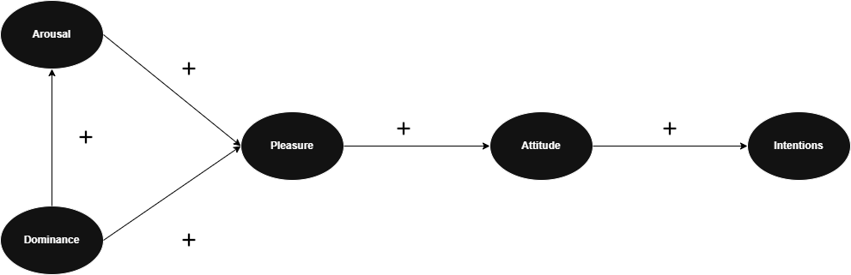
Figure 1. Structural paths among PAD variables and usage intentions
Beyond dimensional theories, appraisal models offer another perspective. The OCC model, proposed by Ortony, Clore, and Collins (Ortony, 1988), suggests that emotions arise from evaluations (appraisals) of events, agents, and objects concerning goals, standards, and attitudes. This model has become foundational for computational emotion systems because it provides a systematic framework for generating emotional responses to narrative events. Calvo and D’Mello (Calvo, 2020), in their thematic review of computational emotion models, highlight the OCC model’s continued dominance, particularly in systems such as the FAtiMA Toolkit (Mascarenhas, 2022), which operationalises appraisal theories for use in virtual agents. Figure 2 represents the FAtiMa toolkit’s architecture diagram, which demonstrates how appraisal models integrate with dialogue and social reasoning systems.
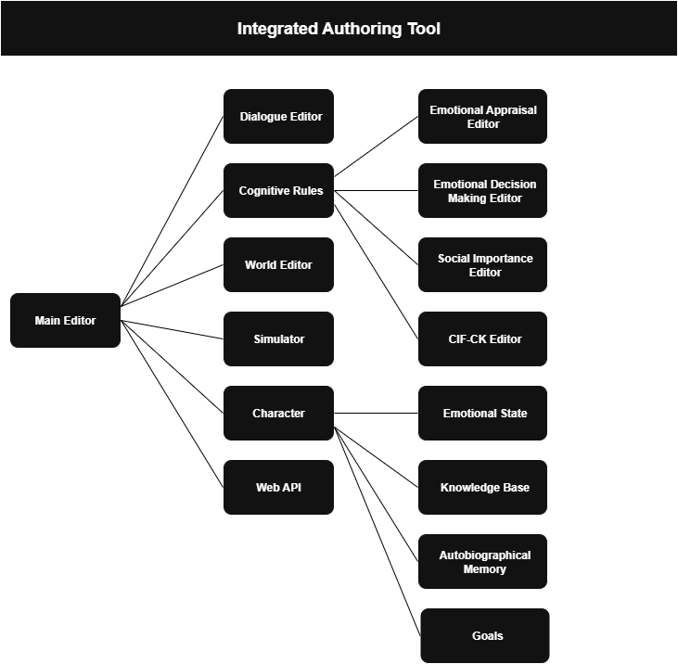
Figure 2. FAtiMa toolkit's architecture diagram

2.3. Computational Personality Models
Parallel to emotion modelling, personality research has significantly influenced the design of believable agents in games and interactive systems. The Five-Factor Model (FFM), also known as the Big Five, has become the dominant framework in psychology for describing personality across five dimensions: openness, conscientiousness, extraversion, agreeableness, and neuroticism (Costa, 1999) (Costa, 1992). Each trait represents a continuum, capturing stable individual differences in cognition, emotion, and behaviour.
The relevance of the Big Five to computational modelling was underscored by Mairesse et al. (Mairesse, 2007), who demonstrated that linguistic cues in dialogue (such as sentence length, pronoun usage, and lexical diversity) could reliably predict personality traits. In their experiments, machine learning models trained on linguistic features achieved significant accuracy in personality recognition, suggesting practical applications in conversational agents. Farnadi et al. (Farnadi, 2016) expanded on this approach, applying computational personality recognition to social media texts and highlighting its feasibility for real-world systems.
For game AI, integrating personality traits enables NPCs to exhibit consistent and differentiated behaviours. Sáez et al., in developing the Moody5 framework (Sáez, 2022), explicitly combined the Big Five traits with emotion models, yielding NPCs whose behaviours reflect both stable personality dispositions and dynamic emotional states. The hybrid architecture of Moody5, shown in Figure 3, illustrates how personality traits influence emotion appraisal and action selection.
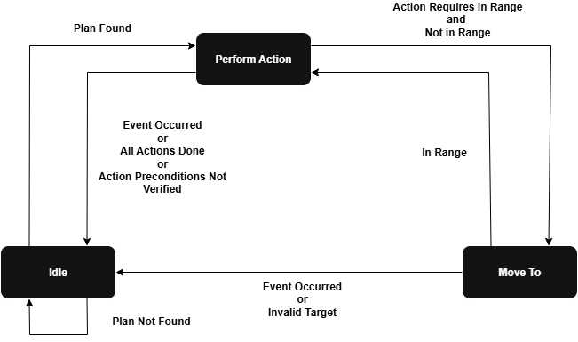
Figure 3. Hybrid architecture of Moody5

2.4. Affective Computing in Games

2.4.1. The Affective Loop
Games offer unique opportunities for affective computing because of their inherently interactive and immersive nature. Chanel and Kivikangas (Chanel, 2020), in their systematic review of affective games, identify the affective loop as a core design paradigm, comprising four stages: elicitation, sensing, detection, and adaptation. In this model, games deliberately provoke emotional responses, sense physiological or behavioural signals, interpret these signals, and adapt gameplay or narrative elements accordingly. Gatzidis et al. (Gatzidis, 2023) similarly emphasises the importance of this loop for creating engaging player experiences.
Yet, as Gatzidis et al. note, commercial adoption of physiological sensing technologies (e.g., EEG, GSR) has been limited by practical constraints, including hardware cost and user comfort. Instead, textual and linguistic analysis offers a non-intrusive alternative for emotion detection, aligning closely with the approach adopted in Space Diplomat. The affective loop diagram shown in Figure 4 provides a practical visual summary of these processes.
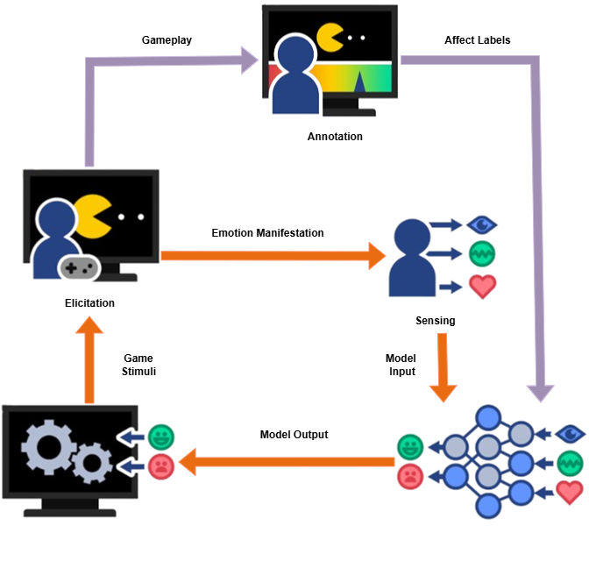
Figure 4. High-level illustration of the affective game loop

2.4.2. Affective Feedback and Engagement
Empirical studies consistently show that affective feedback enhances player engagement. Huisman et al. (Huisman, 2014) conducted experiments demonstrating that games delivering affective feedback (by mirroring or acknowledging players’ emotional states) produced higher immersion scores and longer play sessions compared to non-affective counterparts. This finding resonates with Leite et al. (Leite, 2014), who developed ZOEI, a humanoid robot capable of telling jokes and adapting its behaviour based on real-time affective feedback. The study revealed that users’ rates ZOEI as more engaging and personal when it adjusted its humour style according to the audience’s emotional reactions.
Paiva et al. (Paiva, 2017) extend this discussion in their study on empathy in synthetic characters, arguing that affective agents can evoke empathic responses from users, deepening narrative immersion. In their experiments, users reported higher emotional resonance and memory retention when interacting with emotionally expressive characters, highlighting the potential of affective computing for narrative-driven games.
These findings substantiate the core premise of Space Diplomat: that emotionally aware NPCs can enhance player engagement by creating the illusion of authentic social interactions.

2.5. Affective Reinforcement Learning

2.5.1. Emotion as Intrinsic Motivation
Traditional reinforcement learning algorithms are driven solely by maximizing numerical rewards. However, several researchers have proposed integrating emotional signals into RL frameworks, either as intrinsic motivators or as contextual modulators of policy selection. Barthet et al. (Barthet, 2022), in their influential paper “Play with Emotion”, argue that effective signals can guide exploration by signalling novelty, risk, or potential reward. Their system extends Go-Explore algorithms with emotion-driven selection mechanisms, enabling agents to prioritize emotionally salient states. Figure 5 plots reward convergence for affect-driven versus standard RL agents and demonstrates visually the advantages of incorporating emotional signals.
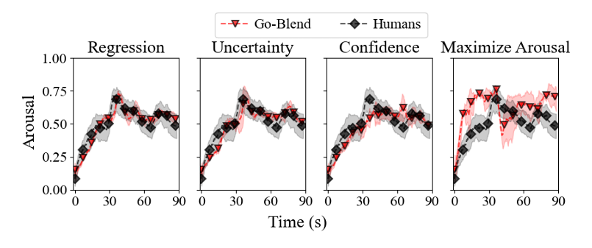
Figure 5.Reward convergence for affect-driven versus standard RL agents
Similarly, Yu et al. (Yu, et al., 2017) provide a survey detailing how affect serves both an intrinsic motivation and as a social signal in RL agents. They categorize emotion’s role in three ways: (1) as intrinsic rewards shaping exploration, (2) as contextual variables influencing policy selection, and (3) as communicative signals for social coordination. This taxonomy is highly relevant to the design of NPCs in Space Diplomat, where emotion modulates both strategic choices and conversational styles.

2.5.2. Practical Applications
Leite et al. (Leite, 2014) provide a compelling application of affective RL in human-robot interaction. In ZOEI, the robot adapts its joke-telling strategies based on feedback such as user smiles or laughter. Over time, ZOEI learns to select humour styles that maximize positive emotional reactions, illustrating how affect-driven adaptation can improve engagement. Wang et al. (Wang, et al., 2023) also demonstrated that integrating pleasure and arousal signals into RL accelerates convergence and produces smoother agent behaviours.
Such studies directly inform the architecture of Space Diplomat, where NPCs use reinforcement learning to adjust their diplomatic tactics based on the emotional cues extracted from player input.

2.6. Believability in Virtual Agents

2.6.1. Defining Believability
Central to creating engaging and immersive NPCs is the concept of believability. Pérez et al. (Pérez, 2016) define believability as the extent to which a virtual agent’s behaviours are perceived as intentional, coherent, and human-like. This perception is influenced by a variety of factors, including consistent emotional expression, personality coherence, context-sensitive reactivity, and social awareness.
What makes an NPC believable is not merely the complexity of its underlying algorithms but the illusion of life it projects to the player. Mairesse et al. (Mairesse, 2007) emphasize that linguistic cues and personality-driven language styles significantly contribute to believability. For example, extraverted agents may use more assertive language and longer utterances, while neurotic characters might express uncertainty or negative emotions more frequently.
Category | Unaware agents | Aware agents | P-value | Significant | ∆
Environment awareness | 0.22 | 0.76 | < .001 | Yes | 0.54
Self-awareness | 0.26 | 0.75 | < .001 | Yes | 0.49
Interaction awareness | 0.30 | 0.77 | .002 | Yes | 0.47
Overall awareness believability | 0.27 | 0.76 | < .001 | Yes | 0.49
Table 1. Believability comparison for aware and unaware agents
Pérez et al. (Pérez, 2016) conducted empirical studies demonstrating that players attribute higher believability to virtual agents who maintain consistent personality traits and emotional responses across interactions. They propose a multi-dimensional model of believability encompassing attributes such as emotional expressiveness, reactivity, self-motivation, and contextual awareness. Table 1 categorizes believability factors and provides a structured framework for assessing NPC believability in Space Diplomat.

2.6.2. Measuring Believability
Quantifying believability remains a challenge. Gatzidis et al. (Gatzidis, 2023) contribute to this area by proposing a detailed scale for assessing virtual agent believability. Their scale includes items measuring:
- Visual realism and consistency of appearance
- Behavioural consistency over time
- Coherence of emotional expressions
- Perceived agency and intentionally
This research is directly applicable to the evaluation phase of Space Diplomat, offering concrete metrics for testing whether alien NPCs are perceived as emotionally authentic and strategically coherent.
In addition, games like Left 4 Dead (Valve Corporation, 2008) and The Last of Us (Naughty Dog, 2013) are often cited for their believable AI companions and enemies. Orkin et al. (Orkin & Roy, 2010) documented how learning social patterns from human gameplay data contributed to NPC believability in Left 4 Dead, allowing NPCs to produce conversational interjections that felt spontaneous and human-like. These insights support the idea that believability emerges from both planned personality expressions and the natural variability seen in human behaviour.

2.7. Linguistic Cues and Dialogue Systems

2.7.1. Personality Detection from Language
Linguistic analysis provides a powerful tool for inferring player emotions and personality traits, enabling NPCs to tailor responses dynamically. Mairesse et al. (Mairesse, 2007) showed that linguistic features (such as word choice, syntactic complexity, and use of hedging language) correlate significantly with the Big Five personality dimensions. This capability has since been validated in large-scale social media studies, including Farnadi et al. (Farnadi, 2016), who demonstrated that personality can be predicted from users’ online textual behaviour with a high degree of accuracy.
This line of research directly informs the Space Diplomat prototype, where players text input is analysed to detect both emotional states and personality tendencies. Such insights allow alien leaders not only to adapt their immediate conversational tone but also to adjust long-term diplomatic stances, making dialogue feel personal and responsive.

2.7.2. Large Language Models in Dialogue
Recent advances in Large Language Models (LLMs) have revolutionized natural language generation. However, as noted by Meta AI in their seminal paper on Human-Level Play in the Game of Diplomacy (M. Bakthin, 2022), purely language-driven models fall short in contexts requiring strategic consistency. In Diplomacy (Avalon Hill, 1959), a game of negotiation and alliances, Cicero (Meta AI) combines LLMs for natural language generation with reinforcement learning to maintain alignment between language outputs and strategic intentions. This dual architecture allowed Cicero to produce not only grammatically correct but strategically coherent communications, a capability purely generative models lack.
This architecture is strikingly similar to the design goals of Space Diplomat, where the Groq LLM is responsible for generating alien leader dialogue, but high-level intentions are dictated by a GOAP framework and RL policy. This ensures that alien leaders’ conversations remain consistent with both emotional states and overarching diplomatic goals.
Moreover, Zhou et al. (Zhou, 2020) emphasize that dialogue systems trained only for next-token prediction often produce contextually disjointed conversations. They propose end-to-end RL training for dialogue policies that consider dialogue-level objectives rather than merely sentence-level coherence. This insight is highly pertinent to Space Diplomat, where maintaining a consistent personality and emotional tone across multi-turn conversations is crucial for believability.

2.8. Tools and Frameworks for Emotion and Personality Modelling

2.8.1. FAtiMA Toolkit
A significant advancement in socio-emotional agent design is the FAtiMA Toolkit (Mascarenhas, 2022). FAtiMA provides modular components for:
- OCC-based emotional appraisal.
- Social reasoning
- Dialogue planning
Mascarenhas et al. demonstrate that the toolkit can be integrated into real-time interactive narratives, enabling agents to reason about emotional impacts and choose contextually appropriate dialogue. Figure 2 show how emotion and social reasoning modules connect with dialogue systems.
FAtiMA’s flexibility and modularity make it particularly suitable for integration into game engines like Unity, aligning well with the architectural goals of Space Diplomat.

2.8.2. Moody5 Framework
Similarly, Sáez et al. (Sáez, 2022) developed the Moody5 framework, which blends Ekman’s basic emotions with the Big Five personality traits to drive GOAP-based action selection in Unity-based storytelling games. Their experiments revealed that NPCSs using Moody5 were perceived as significantly more engaging and less repetitive than those following static dialogue trees. Figure 3 maps personality traits to emotion intensities and behavioural tendencies, is relevant to this project, as it shows visually communicates how personality and emotion interact to shape behaviour.
These frameworks provide practical blueprints for the kind of emotionally adaptive systems implemented in Space Diplomat.

2.9. Stress and Extreme Emotional States

2.9.1. Modelling Stress
Beyond modelling typical emotions, affective computing research has begun to address extreme emotional states such as stress and panic. Roper and ElSayed (Roper, 2020) model stress responses in combat NPCs, drawing on the Fight-Flight-Freeze system from Reinforcement Sensitivity Theory (Gray, 1982). Their finding suggests that high stress levels increase decision-making volatility and can lead agents to deviate from rational strategies, reflecting behaviours observed in human psychology.
In the context of Space Diplomat, such insights are vital for modelling alien leaders who may behave unpredictably under diplomatic crises or threats, abandoning prior commitments or adopting extreme policies. Incorporating stress modelling can make NPCs appear not only more human-like but also more narratively compelling.

2.10. Learning Emotionally Aligned Dialogue Policies

2.10.1. End-to-End Policy Learning
While large-scale language models excel at generating fluent text, they often lack coherence across extended dialogues. Zhou et al. (Zhou, 2020) addressed this challenge by developing an end-to-end RL framework for goal-oriented dialogue policy learnings. Their method trains agents to optimize entire conversation trajectories rather than individual utterances, ensuring consistent pursuit of conversational goals. This is particularly relevant for Space Diplomat, where alien leaders must balance short-term conversational tactics with long-term diplomatic strategies.

2.11. Data-Driven Social Behaviour
Orkin et al. (Orkin & Roy, 2010) propose an intriguing alternative to purely hand-crafted dialogue models: learning social behaviour directly from human gameplay data. In their study of Left 4 Dead (Valve Corporation, 2008), they used collective human gameplay logs to train a probabilistic model capable of generating NPC dialogue that mirrored natural human social patterns. This approach produced more believable NPCs, capable of uttering contextually appropriate phrases such as warnings, tactical suggestions, or humorous comments.
Such data-driven models could significantly enhance the realism of alien leader dialogue in Space Diplomat, allowing NPCs to incorporate natural conversational flow and variability into diplomatic interactions.

2.12. Conclusion
The reviewed literature paints a clear picture: building emotionally believable and engaging NPCs requires an integration of diverse technologies. Computational emotion models like OCC and PAD provide the structure for simulating affective states, while personality frameworks such as the Big Five shape how characters interpret and respond to events. Affective reinforcement learning has emerged as a promising paradigm, enabling agents to adapt not only strategically but emotionally over time. Advances in LLMs have unlocked unprecedented flexibility in dialogue generation, but maintaining consistency and strategic coherence demands the guidance of high-level policies, whether through GOAP or reinforcement learning frameworks. Finally, the concept of believability underscores the necessity of aligning all these systems to produce characters that players perceive as intentional, emotionally authentic, and consistent over repeated interactions.
Space Diplomat seeks to unify these strands into a single architecture where alien leaders respond dynamically to player emotions, maintain coherent personalities, and pursue evolving diplomatic goals. As the reviewed literature demonstrates, such a synthesis represents not only a technical challenge but also an opportunity to push the boundaries of what game AI can achieve in creating engaging, emotionally resonant narratives.

Chapter 3 Methodology

3.1. Technical Architecture and Project Structure

3.1.1. Overall System Diagram
.

3.1.2. Core Unity Framework
.

3.2. Conversational AI Pipeline

3.2.1. NLP Pre-processing
.

3.2.2. LLM Integration
.

3.3. Affective State Modelling

3.3.1. Personality and Trait Mixing
.

3.3.2. Affect Dynamics
.

3.4. Reinforcement Learning and GOAP Integration

3.4.1. RL Agent Design
.

3.4.2. GOAP Dialogue Planner
.

3.5. External Frameworks and Future Add-Ins

3.5.1. FAtiMa and Moody5
.

3.6. Evaluation Design

3.6.1. User Study Protocol
.

3.6.2. Metrics and Logging
.

3.7. Tools and Development Environment
.

Chapter 4 Results

4.1. Affect Dynamics Logged per Interaction
.

4.2. Survey Data
.

4.3. Open-Ended Feedback
.

Chapter 5 Discussion

5.1. Emotional Dynamics and Negotiation Success
.

5.2. Player Perceptions
.

5.3. Limitations
.

5.4. Linking Back to Literature

.

Chapter 6 Conclusion and Future Work

6.1. Conclusions
.

6.2. Future Work

.

References
Barthet, M. R. F. &. D. J., 2022. Play with Emotions: Affect-Driven Reinforcement Learning. s.l., Proceedings of the 2022 International Conference on Affective Computing and Intelligent Interactive (ACII), IEEE, pp. 1-8.
Calvo, R. &. D. S., 2020. Computational Emotion Models: A Thematic Review. IEEE Transactions on Affective Computing, 11(1), pp. 3-21.
Chanel, G. &. K. J., 2020. A Systematic Review of Affective Games. Entertainment Computing, Volume 33, p. Artcile 100348.
Costa, P. &. M. R., 1992. Revised NEO Personality Inventory (NEO-PI-R). s.l.:Psychological Assessment Resources.
Costa, P. &. M. R., 1999. A Five-Factor Theory of Personality. New York: Guilford Press.
Dias, A. M. S. &. P. A., 2022. A Framework for Creating NPCs with Psychologically-Driven Decisions. ACM Transactions on Interactive Intelligent Systems, 12(2), pp. 1-30.
Ekman, P., 1999. Basic Emotions. In: Handbook of Cognition and Emotion. s.l.:Wiley, pp. 45-60.
Farnadi, G. e. a., 2016. Computational Personality Recognition in Social Media. User Modeling and User-Adapted Interaction, 26(2-3), pp. 109-142.
Gatzidis, C. e. a., 2023. Affective Game Computing: A Survey. Entertainment Computing, Volume 46.
Gray, J. A., 1982. The Neuropsychology of Anxiety: An Enquiry into the Functions of the Septo-Hippocampal System. Oxford: Oxford University Press.
Hall, D. &. P. N., 2013. Using the PAD Model to Explain Facebook Attitudes and Use Intentions. Computers in Human Behavior, 29(3), pp. 943-955.
Huisman, G., 2014. Affective Feedback in Video Games: Enhancing Player Engagement Through Emotion Recognition. Entertainment Computing, 5(2), pp. 81-89.
Leite, I. e. a., 2014. Applying Affective Feedback to Reinforcement Learning in ZOEI. IEEE Transactions of Affective COmputing, 11(1), pp. 45-55.
M. Bakthin, A. C. M. L. e. a., 2022. Human-Level Play in the Game of Diplomacy by Combining Language Models with Strategic Reasoning. Science, 378(6624), pp. 1067-1074.
Mairesse, F. e. a., 2007. Using Linguistic Cues for the Automatic Recognition of Personality in Conversation and Text. Journal of Artificial Intelligence Research, Volume 30, pp. 457-500.
Mascarenhas, S. e. a., 2022. The FAtiMA Toolkit: Towards an Accesible Tool for the Development of Socio-EMotional Agents. ACM Transactions on Interactive Intelligent Systems, 12(2).
Mehrabian, A., 1996. Pleasure-Arousal-Dominance: A General Framework for Describing and Measuring Individual Differences in Temperament. Current Psychology, 14(4), pp. 261-292.
Orkin, J. & Roy, D., 2010. Automatic Learning and Generation of Social Behavior from Collective Human Gameplay. s.l., Proccedings of AAMAS, pp. 1151-1158.
Ortony, A. C. G. &. C. A., 1988. The Cognitive Structure of Emotions. Cambridge: Cambridge University Press.
Paiva, A. e. a., 2017. Learning by Feeling: Evoking Empathy with Synthetic Characters. IEEE Transactions on Affective Computing, 8(1), pp. 86-98.
Pérez, R. e. a., 2016. What Makes Virtual Agents Believable?. Computers in Human Behavior, Volume 58, pp. 759-768.
Roper, A. &. E. N., 2020. Modelling Stress Levels in Combat NPCs. Entertainment Computing, Volume 34, p. Article 100362.
Russell, J. A., 1980. A circumplex Model of Affect. Journal of Personality and Social Psychology, 39(6), pp. 1161-1178.
Sáez, A. e. a., 2022. Moody5: Personality-biased Agents to Enhance Interactive Storytelling in Video Games. IEEE Transactions on Games, 14(1), pp. 24-37.
Sáez, A. e. a., 2024. Affective Computing Methods for Simulation of Action Scenarios in Games. Entertainment Computing, Volume 46, p. Article 100501.
Wang, Q. et al., 2023. RLVER: Reinforcement Learning with Verifiable Emotion Rewards for Empathetic Agents. s.l., Association for Computational Linguistics, pp. 666-678.
Yu, H., Shen, Z., Miao, C. & Leung, C., 2017. A Survey of Emotion-Based Reinforcement Learning. s.l., s.n.
Zhou, L. e. a., 2020. End-to-End Offline Goal-Oriented Dialog Policy Learning via Policy Gradient. Proceedings of EMNLP.

Ludography
Avalon Hill, 1959. Diplomacy. Baltimore: Avalon Hill.
Naughty Dog, 2013. The Last of Us. Santa Monica: Sony Computer Entertainment.
Valve Corporation, 2008. Left 4 Dead. Bellevue: Valve.

Appendices

This

